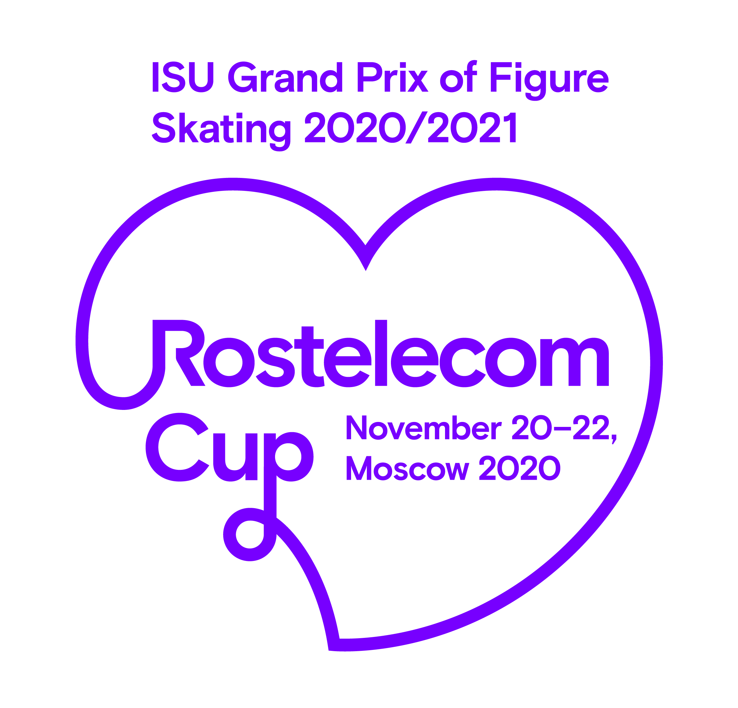АCCREDITATION FORM
ISU Grand Prix of Figure Skating 2020/2021 Rostelecom Cup
November 20-22, Moscow

Media:
__________________________________________________________________
Name and surname:

Category of accreditation:
Writing press_____ Photographer _____ Non Right Holder TV ___________

Agreement with the ISU Guidelines COVID-19 pandemic for Media https://isu.org/media-centre/accreditations/media and Accreditation concept and rules of procedure for media representatives during the ISU Grand Prix of Figure Skating 2020/21 Rostelecom Cup https://dszm.ru/press/isu-gran-pri-rostelecom-cup.html:

Informed ________ _________________ __________ (signature) (name, surname) (data)

Editor-in-chief's signature ______________ stamp _________________
------------------------------------------------------------------------------------------------------------
Please send the completed form at the latest 6:00 p.m. November 16, 2020 by e-mail: press@dszm.ru
If you need more information, or have questions, please contact:
Mrs. Valeria Klyueva
Tel./Fax: +7 495 695 88 64
Email: press@dszm.ru

