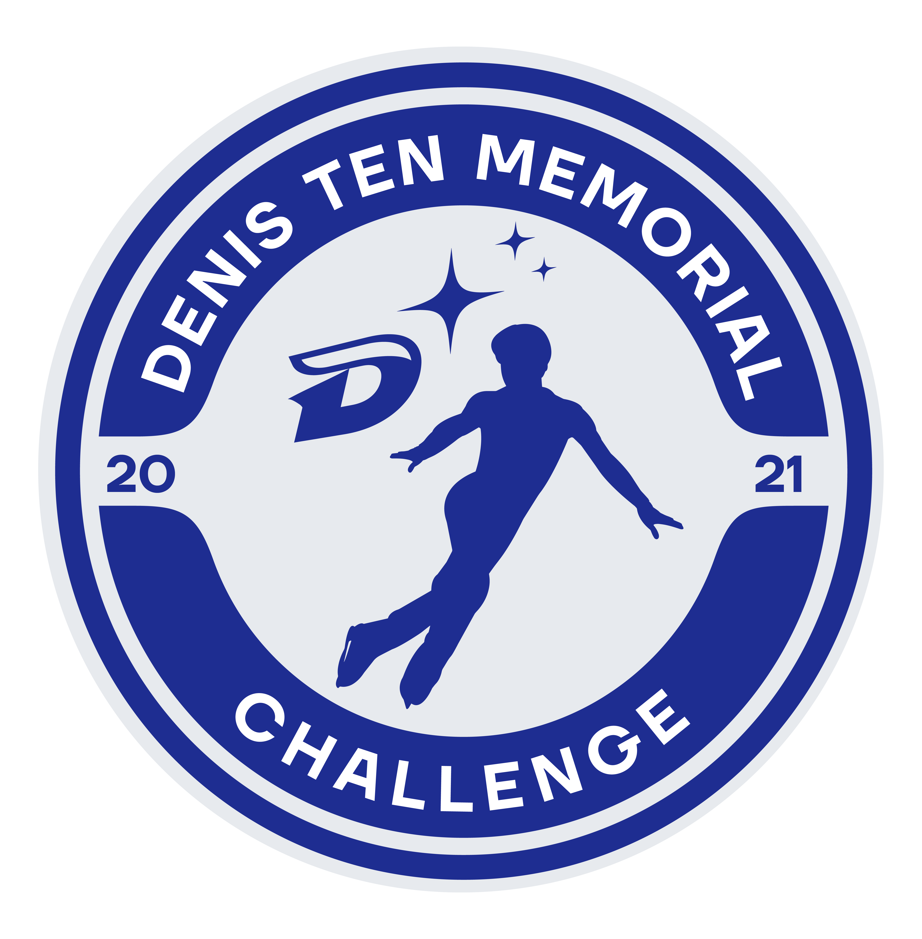

Denis Ten Memorial Challenge

Almaty, Kazakhstan

October 26-29, 2022

ANNOUNCEMENT

Denis Ten Memorial Challenge

Junior Competition for

Men, Women and Ice Dance

organized by

Denis Ten Foundation
National Skating Federation of Kazakhstan

Almaty, Kazakhstan
October 26-29, 2022

- GENERAL REGULATIONS

The Denis Ten Memorial Challenge will be conducted in accordance with the ISU Constitution and General Regulations 2022, the Special Regulations & Technical Rules Single and Ice Dance 2022, and the relevant ISU Communications.

Participation in the Denis Ten Memorial Challenge is open to all Competitors who belong to an ISU Member, and qualify with regard to eligibility according to Rule 102, provided their ages fall within the limits specified in Rule 108, paragraph 3 a) and they meet the participation, citizenship and residency requirements in Rule 109, paragraphs 1 through 5 and ISU Communication 2030 or any update of this Communication.

In accordance with Rule 109 of the ISU General Regulations and ISU Communication 2030 all Skaters who do not have the nationality of the Member by which they have been entered or who, although having such nationality, have in the past represented another Member, must produce an ISU Clearance Certificate. Passports of all Skaters, as well as the ISU Clearance Certificate, if applicable, must be presented at the accreditation of the event for verification.

All competitors must be entered through their respective ISU Member Federation.

- TECHNICAL DATA

PLACE | Main arena: “Halyk Arena” Ice Palace, Almaty, av. Kuldginskiy tract 2  (an indoor ice-rink with the ice surface of 30 x 60 m, air-conditioned and heated)  Practice arena: “Halyk Arena” Ice Palace, Almaty, av. Kuldginskiy tract 2  (an indoor ice-rink with the ice surface of 30 x 60 m, air-conditioned and heated)  Main and Practice Rink are in the same complex / building

JUNIOR MEN | Short Program | The required elements to be skated are those listed in ISU Technical Rules Single & Pair Skating 2022 Rule 611, paragraphs 1 and 3 for 2022/23(and listed in ISU Communication no. 2382).  Duration: 2 minutes and 40 seconds, +/- 10 sec.
 | Free Skating | In accordance with ISU Technical Rules Single & Pair Skating 2022, Rule 612 and the respective ISU Communication. Special attention should be paid to the “well balanced program” and the element value.  Duration: 3 minutes and 30 seconds, +/- 10 sec.
JUNIOR WOMEN | Short Program | The required elements to be skated are those listed in ISU Technical Rules Single & Pair Skating 2022, Rule 611, paragraphs 1 and 3 for 2022/23 (and listed in ISU Communication no. 2382).  Duration: 2 minutes and 40 seconds, +/- 10 sec.
 | Free Skating | In accordance with ISU Technical Rules Single & Pair Skating 2022, Rule 612 and the respective ISU Communication. Special attention should be paid to the “well balanced program” and the element value.  Duration: 3 minutes and 30 seconds, +/- 10 sec.
JUNIOR ICE DANCE | Rhythm Dance | In accordance with ISU Technical Rules Ice Dance 2022, Rule 709.  Rhythms, required elements and guidelines are those listed in ISU Communication 2468 and subsequent updates.  Duration: 2 minutes and 50 seconds, +/- 10 sec
 | Free Dance | In accordance with ISU Technical Rules Ice Dance 2022, Rule 710. The required elements to be skated are those listed in ISU Communication 2468 and subsequent updates.  Duration: 3 minutes and 30 seconds, +/- 10 sec.

- ENTRIES

3.1 Entries of Competitors.
ISU Members must enter their competitors/couples using the entry forms (no more than three participants/couple in each discipline)
All competitors must be entered through their respective Member Federation/Association.

The OC reserves the right to limit the number of participants in each category in case of overcrowding.
The preliminary entries (by number) must reach the Organizing Committee by latest: September 20, 2022

Entries by names must be sent not later than Friday, – September, 30, 2022 – 20:00 h (local time Almaty)

Denis Ten Memorial Challenge Organizing committee
“KOKTEM-1” Microdistrict, 11
Almaty City
e-mail: tendenis.memorial@gmail.com
tel. +7(727)328 03 14
mobile +7(701)733 07 34

3.2 Entries of Judges.
Each participating Federation should nominate one judge with the qualification “Judge for International competitions” or “ISU Judge” and the second one in case of the entry for the Ice Dance event (the second judge should have the qualifications for both categories – Ice Dance and Figure Skating). The judges have to be on the current ISU list of judges (ISU Communication No. 2502). The organizer decides on the composition of the panel of judges. In case of too many nominated judges, the organizer will draw the judges' panel after the entries' closing date. The written confirmation will be sent to each federation immediately. All judges must be entered through their respective Member Federation/Association. Entries must be sent not later than September 20, 2022 – 20:00 h (local time of Almaty)

3.3 Entries of Team Officials.
Official entries of Team Leaders, Coaches/Choreographers, chaperones etc., must be made together with Competitor’s entries using the official entry forms.
Please be advised that only one Coach per Skater will be accredited.

3.4 Entry Fee

The entry to the competition is Free

- MEALS, LODGING AND TRAVEL EXPENSES

The organizer will provide and cover the expenses for rooms and meals for all Referees, the Technical Controllers, the Technical Specialists, the Data and Replay Operators and Judges participating, beginning with dinner on October, 25 until breakfast on October, 30.

Should any of the above-mentioned persons arrive at the hotel before or stay longer than the period described above, their room costs and expenses will be the responsibility of the individual and must be paid on arrival.

The Organizing Committee will cover the costs for travel expenses for all Referees, the Technical Controllers, the Technical Specialists, the Data and Replay Operators.

- PRACTICE

Official practice for Competitors begins on Thursday, October, 26, 2022.

- MUSIC / PLANNED PROGRAM CONTENT

All Competitors shall furnish competition music of excellent quality on CD in any other approved format, in accordance with Rule 343, paragraph 2. A list of titles, composers and orchestras of the music to be used for the Short Program and Free Skating Program for Single and Pairs, for the Short and Free Dance Program for Ice Dance and for the Exhibition must be entered on the ISU Portal. Members can download the entered information to send to the Organizing Committee.

In accordance with Rule 343, paragraph 2, all covers/discs must show the Competition event, Competitor’s name, the Nation and the exact running time of the music (not skating time) including any starting signal and must be submitted at the time of registration. Each program (short program, free skating, short dance, free dance) must be recorded on a separate disc. In addition competitors/couples must provide a back-up drive for each program.

If music information is not complete and/or the music is not provided, accreditation will not be given.

The Planned Program Content must return to the OC at the accreditation latest. The Program Content Sheet must be filled in precisely by each Skater in English using the respective ISU Communication elements' terminology.

- ARRIVAL OF PARTICIPANTS / TEAMS

The nearest airport to Almaty is ALA Airport with a distance of 16,7 km to the official hotel.

The Organizing Committee provides a bus shuttle to meet the teams on arrival.

All Referees, the Technical Panel (Technical Controllers, Technical Specialists, Data & Replay Operators) Judges, Competitors, Team Leaders, Team Officials, Team Medical Staff and Coaches are requested to announce to the Organizing Committee as soon as possible but no later than October 10, 2022 - 20:00 h (local time of Almaty). the name of the airlines, flight numbers, dates and times of arrival or any other information concerning transportation and arrivals.

- OFFICIAL HOTEL(S)

HOTEL “NOVOTEL Almaty City Center” 4 stars

ADDRESS: 104A Dostyk Avenue, A25D5Y3, Almaty Kazakhstan
phone: + 7 727 355 3838
fax: + 7 727 355 3939
web: https://all.accor.com/russia/index.ru.shtml

Organizing Committee may help with booking of the rooms if the booking requests will reach the organizers not later than October 02, 2022. Hotel payments are made upon arrival at the hotel. There is a free shuttle bus transportation service between the Official hotel and the ice rink.

- ACCREDITATION

The official accreditation for Teams is planned at the ICE RINK the upon arrival.

Accreditation as a Team Member will be given to all entered Judges, Competitors and one Team Leader per participating team, one Coach per Competitor, a maximum of two Team Officials of ISU Members (including the Member President), provided that they are Council Members, Technical Committee Members or Members of the Head Office of their Federation and a maximum of two medical persons. Accreditation will only be granted to persons in those various functions if officially entered and named through their ISU Member. The ISU Member certifies with the signed entry form the indicated functions within the team of all team members. Any misuse of any function will be sanctioned by the ISU/OC.

Accreditation will be given to appointed Event Officials and Guests.

Chaperons will not receive accreditation.

- RESULTS

The marking system (ISU Judging System) as described in ISU Technical Rule Single & Ice Dance 2022, Rule 352 and Rule 353 (Determination and publication of results) will be used.

- PRESENTATION OF MEDALS AND PRIZE

The three best placed Skaters/Couples in each event will be announced and honored. Gold, silver and bronze medals will be presented to the medalists. The national anthem of the winner will be played and the flags of the medal winners hoisted.

- INSURANCE / LIABILITY

In accordance with Rule 119, it is the sole obligation of each Member participating in ISU Events, to provide medical and accident insurance for their athletes, officials and all other members of the Member’s team. Such insurance must assure full medical attendance and also the return of the ill or injured person to the home country by air transport or by other expeditious. It is an internal matter of each ISU Member to decide the issue who shall pay the premium for such insurance.

The ISU and the Organizing Committee assume no responsibility for or liability with respect to bodily or personal injury or property damage incurred in connection incurred by Competitors and Officials.

- EXHIBITION

Exhibition will take place on Sunday, October 29,2022. The best three placed skaters/couples participated in an exhibition will receive prize money:
 | Women | Men | Ice Dance
1 st place | 300 $ | 300 $ | 500 $
2 nd place | 200 $ | 200 $ | 300 $
3 rd place | 100 $ | 100 $ | 150 $

We will be glad to invite Competitors to take part in the Exhibitory Performances who were warmly accepted by the audience.
Award money will be transferred to the ISU Member by bank transfer.
The withholding tax of Kazakhstan will be deducted.

- MEETINGS FOR ISU EVENT OFFICIALS AND JUDGES

All Referees, Technical Controllers, Technical Specialists, Data and Replay Operators and Judges are responsible to make their travel arrangements in order to be able to attend the respective event related meetings. If any other party makes the flight arrangements, the Referees, Technical Controllers, Technical Specialists, Data and Replay Operators and the Judges are responsible to check if such arrangements are in line with the detailed schedule as mentioned under paragraph 18.

- INFORMATION AND VARIOUS

For information, please contact the Organizing Committee:

Denis Ten Memorial Challenge Organizing committee
“KOKTEM-1” Microdistrict, 11
Almaty City
e-mail: tendenis.memorial@gmail.com
tel. +7(727)328 03 14
mobile +7(701)733 0734

- EVENT SCHEDULE

Tuesday,  October 25, 2022 | All day | Arrival of teams
Wednesday,  October 26, 2022 | All day | Official practice
 |  | Team Leaders Meeting
 |  | Individual Technical Panel Meetings per Discipline
 |  | Referees and Technical Controllers Meeting
 |  | Judges Draw and Meeting
Thursday  October 27, 2022 | 10:00 | JUNIOR WOMEN – Short Program
JUNIOR MEN – Short Program
JUNIOR ICE DANCE – Rhythm Dance
Friday,  October 28, 2022  Saturday,  October 29, 2022 | 10:00 | JUNIOR WOMEN _ Free Program  JUNIOR MEN – Free Program
 | 12.00  17.30 | JUNIOR ICE DANCE – Free Dance  VICTORY CEREMONY JUNIOR WOMEN, WOMEN, ICE DANCE
 | 19:00 | EXHIBITION

Please note:
This schedule is subject to changes and will be updated in accordance with the final number of entries.

FORMS AND DEADLINES

Number | Form | Format | Deadline
N/A | Preliminary Entry Form | Form | September 20, 2022
N/A | Composition of Delegation | Form | September 20, 2022
N/A | Entry Form for Competitors | Form | September 30, 2022
N/A | Entry Form for Judges | Form | September 20 ,2022
N/A | Hotel reservation request | Form | October 02, 2022
N/A | Team Travel Form | Form | October 10, 2022
Form X | Visa request form | Form | September 30, 2022
N/A | Press Information | ISU Portal | Valid for season 22/23
N/A | Competition Music Information | ISU Portal | Valid for season 22/23
N/A | Ice Dance Music Information | ISU Portal | Valid for season 22/23
N/A | Program Content Form | ISU Portal | Valid for season 22/23

